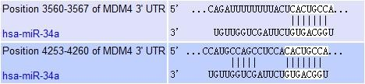
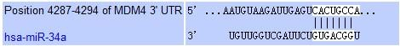
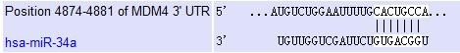
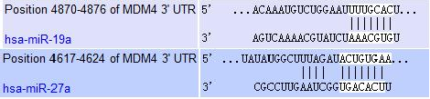
Luciferase reporter assays 1.Predicted consequential pairing of target region and miRNA

2.Getting destination fragment 2.1、obtaining cDNA template
Take a dish of 293T cells, digest it, and centrifuge the cells. Add 1ml Trizol cracking solution

to the cells, ice cracking for 10 minutes and then add 200ul ethanol to it. Treat the cells with 12,000 rpm centrifugation for 3 minutes and then take 400 UL upper liquid to add equal volume isopropyl alcohol and keep in -20°C quiet for 15 minutes.
Treat the mix with 12,000 rpm centrifugation for 3 minutes, abandon the upper liquid. Dissolve the rest with 10 UL DEPC, mix in 1 UL Oligodt, keep in 70°C for 5 minutes and put them on the ice. Formulate the reaction system according to the following table, keep in 37°C for
two hours, store in -20°C for reuse.
2.5 mM dNTP mixture | 1.5μl
5×MMLV buffer | 5μl
RNA | 10μl
OligodT | 1μl
MMLV retrotranscriptase | 1μl
ddH2O | 7.5μl

Total 25μl

2.2 PCR amplification

primer of PCR

A6069-1P+(exon) | CAGACCTCGAGTGTAGAGGTTACCTCTGAGGAT
A6069-1P-(exon) | GTGATGCGGCCGCTCCCATGCTTGAGATGGTCT
A6069-2P+(UTR) | CAGACCTCGAGTACAGGTGTGCACCACCATGTC
A6069-2P-(UTR) | GTGATGCGGCCGCTGTCAAAAGAAAGTACTTCTCAAA
Formulate the PCR reaction system according to the following table, temple quantity is 1μl genome,(Primer concentration: 1OD soluble in 400 UL ddh2O) ：
2.5 mM dNTP mixture 1μl

10×pfu buffer 5μl

cDNA template 1μl

A6069P+(2uM) 1μl

A6069P+ (2uM) 1μl

pfu Polymerase 0.4μl(5u/ul)

ddH2O 41μl
Total 20μl

The reaction conditions are as follows： 95℃ 3 min

94℃ 30 sec

50℃ 30 sec

72℃ 3 min

72℃ 9 min 4℃ store

35Cycles

2.3 PCRproduct recovery and double enzyme cutting

1）After electrophoresis of the PCR product, cut the gel strip containing the target fragment into a clean 1.5 ml EP tube under ultraviolet conditions with the scalpel. And adds the solution BD to the centrifuge tube at a ratio of 100 mg gel to 100 UL solution BD.

- 60℃ Water bath 10 min up to gel completely dissolved, 3 times.

- Transfer solution to DNA purification column, leave for 2 minutes, 12000 rpm centrifuge for 1 min in room temperature, and then discard filtrate.
- Add 500 ul solution PE to column, 12000 rpm centrifuge for 1 min in room temperature , an the discard filtrate.
- Repeat the last operation once.。

- Treat empty column with 12000 rpm centrifuge for 1 min to completely remove the remaining liquid in the purified column.
- Place the column on the new 1.5 ml EP tube, add a sterile water of 30μL 60℃ to the center of

the column, and 12000 rpm centrifuge 1 min to obtain DNA.

8）take 15ul PCR recovery product , treat them in 37℃ with XhoI and Note 1 enzyme cutting for 2 hours and recovery of enzyme cutting product. The enzymatic cutting system is as follows:
ddH2O 0.1%BSA  10×Tango Buffer  PCR product | 23μl 5μl 5μl  15μl
Not1 | 1μl
XhoI | 1μl
Total | 50μl

4 、 psiCHECK-2 vector Double enzyme cutting

37℃ double enzyme cutting overnight; 1% agarose gel electrophoresis, using QIAquick Gel Extraction Kit(QIAGEN) and recovering linearized carrier fragments. The reaction system is listed as follows:
component volume
NotI 1 ul

XhoI 1 ul

10×O buffer 5 ul

psiCHECK-2vector 10 ul(about 1ug)

H2O 33 ul

total 50 ul

5、target fragment combined with psiCHECK-2vectror

The following reaction system is prepared in a sterile 0.5 ml EP tube and is connected overnight at 16℃:

compnent volume
Linearized psiCHECK-2 vector 2 ul(about 100ng)

Target DNA fragment 5 ul(about 300ng)

10xT4 DNA Ligase Buffer 2 ul

T4 DNA Ligase 1 ul

H2O 10 ul

total 20 ul

6、Transformation of Connected Products

- The 5ul connection product was added to 100 ul DH5α receptor cells in the ice bath. Gently rotate and mix, and then ice bath 30 min.
- heat shock 90s in 42℃ Bath.

- Quickly transfer tube to ice bath, ice bath 3 min.

- Add 200μl LB medium, mix evenly, 37℃, 200 rpm oscillation culture for 1 hour.

- The bacteria solution is coated on the surface of the LB plate containing ampicillin, placed at room temperature up to absorption of the liquid. Inverted plate, transferred to 37℃ biochemical culture box for overnight culture.

7、Screening for positive cloning

Cloning of single colonies was selected and identified by XhoI + NoteI dienzyme electrophoresis. At the same time, LBamp or Kana liquid culture medium was inoculated for 8 hours.

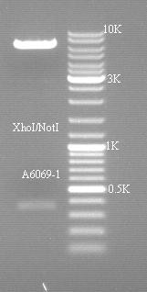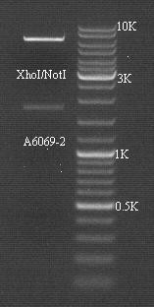
MDM4-exon MDM4-UTR

8、Sequencing and Analysis

Cloning was identified by double enzyme electrophoresis and then sequenced(the carrier was sent to Shanghai bioengineering sequencing), and the clone was retained in accordance with the expected sequence. The Plasmid DNA was extracted after 12 hours of inoculation with LBamp liquid medium 20ml.
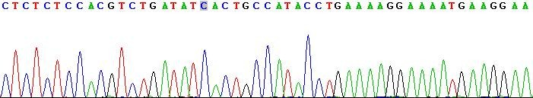
The original results of sequencing are listed in the sequencing document(A6069-1, A6069-2): MDM4 EXON sequencing is as follows：CACTGCC

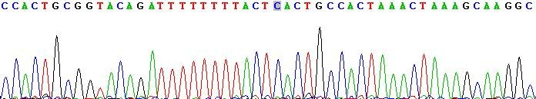
MDM4 UTR sequencing is as follows：CACTGCC、

CACTGCC、CACTGCC

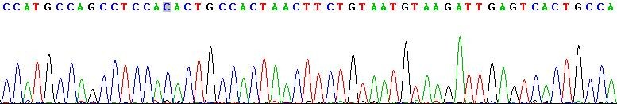

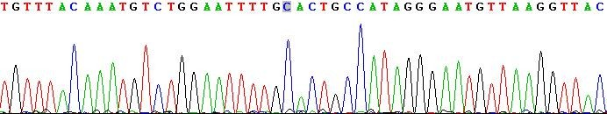
CACTGCC、TTGCAC
ACTGTGA
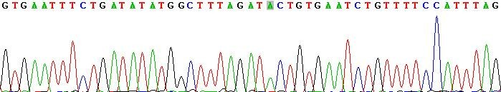

9、Cell transfection

1 、 Use lipofectamineTM 2000(lipo2000) to transfect 48 hole plate
2 、 The day before the transfection, inoculate an appropriate number of 293T cells in the 48-hole culture plate, each hole added culture medium without antibiotics, so that the density of cells can reach 70% ~ 80% during transfection. Groups are set as followed while each with 3 parallel holes:
group | 50nM | 100 ng
1-3 | hsa-miR-34a | psiCHECK-MDM4 UTR
10-12 | Mir-NC | psiCHECK-MDM4 UTR
13-15 | hsa-miR-34a | psiCHECK-MDM4 exon
16-18 | Mir-NC | psiCHECK-MDM4 exon

3 、 For each transfection sample, prepare the Plasmid-lipo2000 mixture as follows:

- Dilute plasmid: Dilute 100 ng psiCHECK-MDM4(V1) with 25ul medium without serum, gently mix.Use 25ul medium without serum to dilute hsa-miR-34a(V2), gently mix.
- Dilute lipo2000: Dilute lipo2000(V3) with 25ul medium without serum, gently mix and incubate 5 min at room temperature;
- Gently mix V1 + V2 with V3 and incubate 20 min at room temperature.

4 、 Add Plasmid-LIPO 2000 mixture to the 48-hole plate containing cells and medium, gently

shaken.

5 、 put the culture plate in 37℃ CO2 culture box for cultivation with 48 hours. After 4 to 6 hours of culture, remove the culture liquid containing the Plasmid-LIPO 2000 mixture from the hole and replace with the fresh medium.

10、Luciferase detection

- After the cell is cracked with a cell cleavage solution, the fluorescence intensity is measured by mixing the 5ul cell cleavage with the Firefly luciferase buffer and the substrate 5ul(as described in the test kit for the promega dual fluorescence reporting system).Then add 5ul marine kidney luciferase reaction buffer and coelenterin substrat , and the activity of marine renal luciferase was measured again.
- Each sample was homogenized according to Firefly luciferase activity. The activity of marine renal luciferase was compared and a chart was drawn.

Note: psiCHECK. -2 Vector uses Firefly luciferase as an internal reference.

Main experimental reagent
name company

Double Fluorescent Report Gene Detection Kit Promega QIAquick Gel Extraction Kit QIAGEN
XhoI NEB

Not1 NEB

PsiCHECK-2Vector Promega

DNA ligation kit TOYOBO

Lipo 2000 Invitrogen

fetal bovine serum Gbico
MicroRNA mimics、Negative control GenePharma

Main experimental instruments
name company

ABI3900High-throughput DNA synthesizer ABI

9700 PCR ABI

EDC-810 PCR
Beijing Dongsheng Innovation Biotechnology

C02culture box(BBD 6620) Thermo Fisher

Cryogenic centrifuge(TDL-5000BR)
Shanghai Anting Scientific Medical Instrument Factory

Desktop centrifuge(5427 R) Eppendorf

Gel Analyze(Gel DocTM XR) Bio-Rad

20℃Ultra-cold refrigerator Sanyo. Fluorescent detector(GloMax 96Microporous plate) Promega Super pure water machine(Milli-Q Biocell) Millipore
pipettor Eppendorf

Super Clean Worktable
Shanghai Boxun Industrial Co. Ltd.. Medical Equipment Factory

Electrophoresis Bio-Rad

Electric Cup Bio-Rad

Electric converter Bio-Rad

Horizontal electrophoresis slot Bio-Rad
Thermothermal rollaway Beijing Liuyi Instrument Factory

